TOP 5 Best – Selling Product By Revenue
Instead of looking at marketing channels, this query Pivots to looking entirely at inventory metrics to find which individual items brought in the most revenue.

QUERY-;

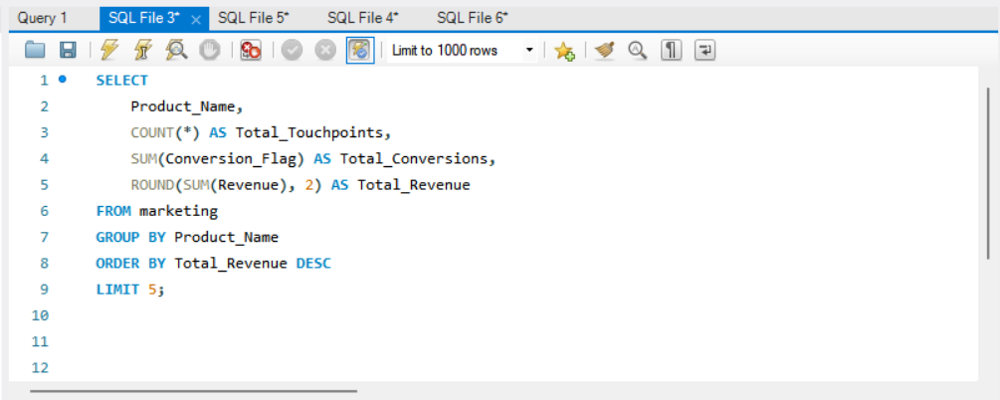

SOLUTION-;

